**FPT ACADEMY INTERNATIONAL**



## FPT – APTECH COMPUTER EDUCATION

CLEARREFLECTIONS

|  |  |  |  |
| --- | --- | --- | --- |
| **Center Name** | | FPT – Aptech – HCM2  Address: 590 Cach Mang Thang Tam, District 3, Ho Chi Minh City | |
| **Instructor** |  | Ms. Le Mong Thuy |  |
| **Class** |  | T1.2303.M0 |  |
| **Group** |  | 3 |  |
| **Group members** | | **Name** | **Student ID** |
|  |  | Le Duc Minh | Student1459123 |
|  |  | Ha The Doanh | Student1459374 |
|  |  | Le Tan Thanh | Student1459118 |
| **Duration** | Start date | 19th June 2023 |  |
| End date | 26th Jul 2023 |  |

**This is to certify that**

**Mr.:**

Ha The Doanh

Le Duc Minh

Le Tan Thanh

**has successfully designed & developed**

eProject: ClearReflections

**Submitted by:**

Le Duc Minh

**Date of issue:**

**Authorized Signature:**

**TABLE OF CONTENTS**

***FPT – APTECH COMPUTER EDUCATION***

***TABLE OF CONTENTS*** ***2***

***ACKNOWLEGMENT*** ***3***

***SYNOSIS*** ***3***

***PROBLEM DEFINITION*** ***3***

***CUSTOMER'S REQUIREMENTS SPECIFICATIONS (CRS)***

***Business/Project Objective*** ***4***

***Hardware/ Software Requirements*** ***5***

***SCOPE OF THE WORK (IN BRIEF)***

***Architecture and design of the system***

***Diagram of the website***

***TASK SHEET REVIEW 1***

***SITE MAP 10***

***MOCK OF THE WEBSITE*** ***12***

***1. Homepage*** ***13***

***2. Product*** ***14***

***3. Blog*** ***15***

***4. Service*** ***16***

***5******. About us*** ***17***

***TASK SHEET REVIEW 2 18***

WEBSITE DESCRIPTION **1****9**

RESPONSIVE****28****

[**JAVASCRIPT DESCRIPTION**](#Javascript) **29**

**TASK SHEET REVIEW 3** ****3**5**

# ACKNOWLEGMENT

On behalf of team members. I would like to thank everyone who supported my team to successfully complete this eProject report. Especially, our teacher, she has supported us a lot since we started studying at FPT Aptect. With this eProject, she guided us very meticulously, enthusiastically and strictly. With her guidance, we were able to successfully complete this project. Besides, I also want to thank all the team members, each of whom worked hard to complete the eProject in earnest during the month of working together. Finally, our group would like to say thank you to my classmates and family for sharing and creating for the group the best environment to focus on the project, motivating the members to achieve their goals.

# SYNOSIS

# The goal of the eProject is that we need to create a website that meets all the requirements of the client, Clear Reflection. Clear Reflections is an organization selling mirrors. They sell varieties of mirrors of different types suiting every requirement and into various sizes/shapes, starting from office to home and etc. They always satisfy customers with professional staff with many years of experience.. Customer satisfaction is always the top goal of Clear Reflections.

# PROBLEM DEFINITION

The Web site is to be created based on the following requirements.

1) The Home Page should be created making use of Sections with a suitable

logo, the header section can be added which will show images chairs.

2) The site must contain the links to navigate through any category for the

information.

3) The site should display a menu which will contain the options for brief

introduction about the various mirrors available, location of the shop and any

other information if required.

4) The information should be categorized according to the type of the mirrors

like if a User wants to see only “drawing room mirrors” or any other category

chairs then he/she can click on a Link/button/menu etc and can see only that

type mirror.

5) A brief summary of about the mirrors should be displayed on the Web Page

along with the picture but detailed Features should be stored in Individual

Word documents which can be downloaded or viewed by the User who wishes

to see the same.

6) The sample categories can be

- Drawing/Living room mirrors

- Bathroom mirrors

- Dressing mirrors

- Bedroom mirrors

- ….

- user can add categories of their own choice too.

7) There should also be categorization depending on material like- Wooden framed

- Acrylic bordered

- Metal bordered

- Decorative mirrors

- LED mirrors

- Bluetooth mirrors

8) There should be a “Contact Us” page which will have the Address of the

Company which should be displayed using GeoLocation API (eg. GoogleMaps)

and the email address which when clicked will invoke the local mail client

from where they can send an email.

# CUSTOMER'S REQUIREMENTS SPECIFICATIONS (CRS)

**Client: Clear Reflections**

### Business/Project Objective:

This website is intended to promote Clear Reflections' famous image specializing in mirrors. This group specializes in all types of mirrors from popular to modern.

You are supposed to create a website for them with the below mentioned requirement specifications.

The website is to be developed for the Windows Platform using HTML5, JavaScript and Geolocation. The site should work well in all leading browsers including Chrome, IE, Firefox etc.

**Input to the system:**

- Searching products based on User and Customer of Clear

- Feedback about the quality of products

**Output from the system:**

- Perform contain the options for brief introduction about the various mirrors available, location of the shop and any other information if required.

- Display results for each type of product according to the search content.

- Display product information by categories, price, specifications, brand, image, color, model...

- Display the special information and best seller of the product.

- Display products of the same type, same brand, other related products.

- Customers can also be downloaded or viewed imgaes by the User who wishes to see the same.

- The email address which when clicked will invoke the local mail client

from where they can send an email.

- The location of the shop under Contact-Us page.

**Process**:

* + - * Validate data input from users.

**Expected delivery date:** 26-July-2023.

**List of deliverables:**

- Document Word, PDF.

- User Guide.

- Source code.

### Hardware/ Software Requirements:

* **For developer**

**Hardware**

* + Intel Pentium 4 processor or higher
  + 01 Gigabytes of RAM or higher

**Software**

* + Windows 7 OS or higher
  + Adobe Dreamweaver
  + Web browsers such as IE, Chrome or Firefox are supporting HTML5, CSS3 and Javascript.
* **For web users**

**Hardware**

* + Intel Pentium 4 processor or higher
  + 512 Megabytes of RAM or higher

**Software**

* + Windows XP OS or higher
  + Web browsers such as IE, Chrome or Firefox are supporting HTML5, CSS3 and Javascript.

# SCOPE OF THE WORK (IN BRIEF)

After a long and detailed discussion, our group has decided to create a website contain the following webpages:

1. ***Homepage***: There is a search bar to search for products, display promotional information, best-selling products and introduce Clear Reflections.
2. ***Product***: Displays all available products based on the category (Wooden framed , Acrylic bordered,Metal bordered, Decorative mirrors, LED mirrors and Bluetooth mirrors). In the above categories, products can be filtered by name, capacity and price.
3. ***Blog***: Display articles, news, equipment installation instructions...
4. ***Contact Us***:GeoLocation API (eg. GoogleMaps) and the email address which when clicked will invoke the local mail client from where they can send an email.
5. ***Service***: Displays user inquiries, product documents, and product price lists for user downloads, freight services, and equipment installation.
6. ***Sign In/ Sign Up***: Allow users sign up or sign in to the website.

# ARCHITECTURE AND DESIGN OF THE SYSTEM

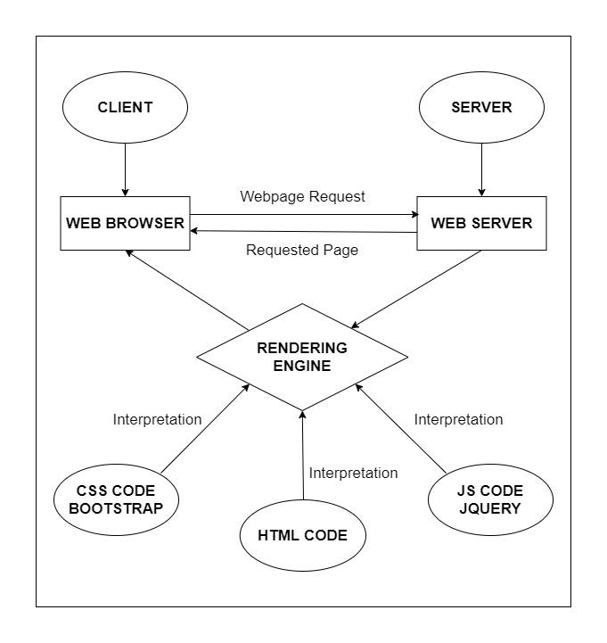

# DIAGRAM OF THE WEBSIT



# TASK SHEET REVIEW 1

|  |  |  |  |  |  |  |  |
| --- | --- | --- | --- | --- | --- | --- | --- |
| **Project Ref. No.:**  **eP/Advertisement Portal Management**  **System/01** | | **Project Title:** | **Activity Plan Prepared By:** | **Date of Preparation of Activity Plan:** | | | |
| **Sr.**  **No.** | **Task** | **Actual**  **Start**  **Date** | **Actual Days** | **Team**  **Mate Names** | **Status** |
| 1 | Problem Statement | Clear Reflections | Minh | 23-Jun-23 | 1 | Minh | Completed |
| 2 | Analysis of Harvel Electric requirements about the website | 23-Jun-23 | 1 | Minh | Completed |
| 3 | The scope of the work (in brief) | 23-Jun-23 | 1 | Doanh | Completed |
| 4 | Architecture and design of the system | 23-Jun-23 | 1 | Doanh | Completed |
| 5 | Diagram of the website | 23-Jun-23 | 1 | Thanh | Completed |
| 6 | Task Sheet | 23-Jun-23 | 1 | Thanh | Completed |
|  |  |  |  |  |  |  |  |

|  |  |
| --- | --- |
| **Date:** | |
| Signature of Instructor:  **Ms. Le Mong Thuy** | Signature of Team Leader:  **Le Duc Minh** |

# SITE MAP

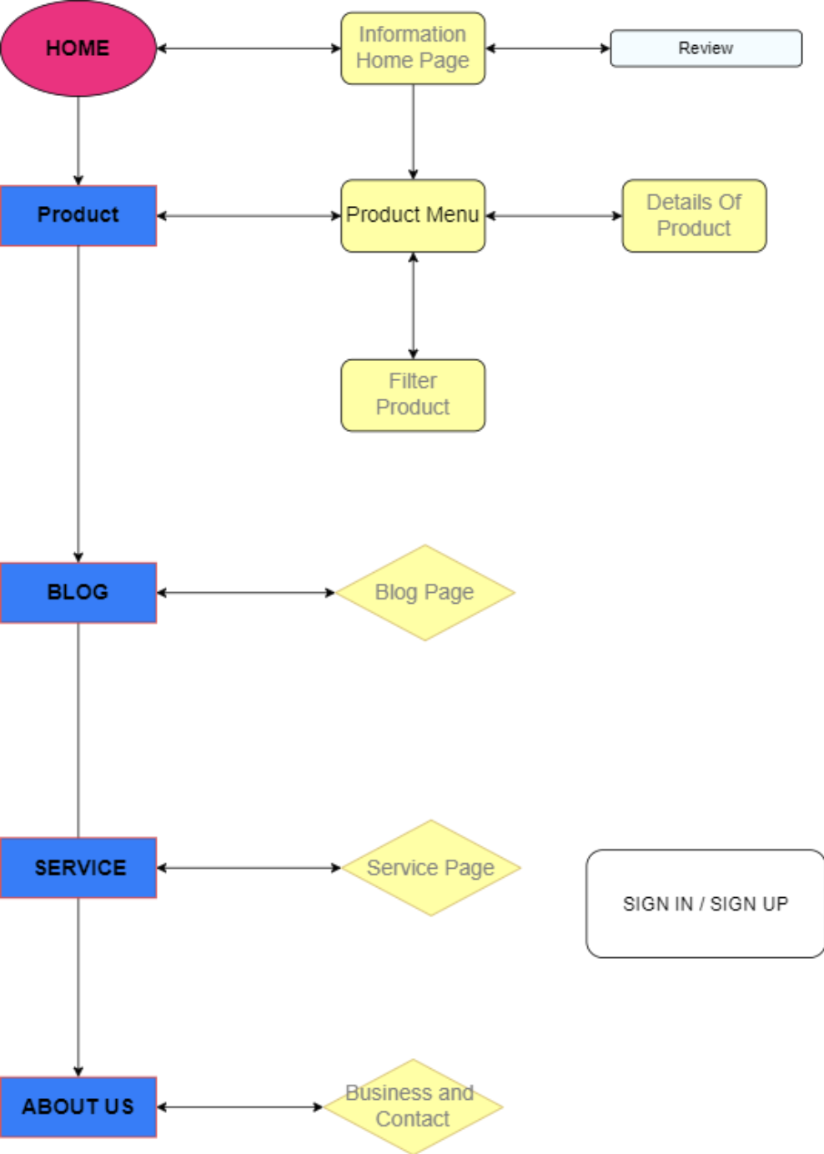

# MOCK OF THE WEB SITE

1. **Homepage**

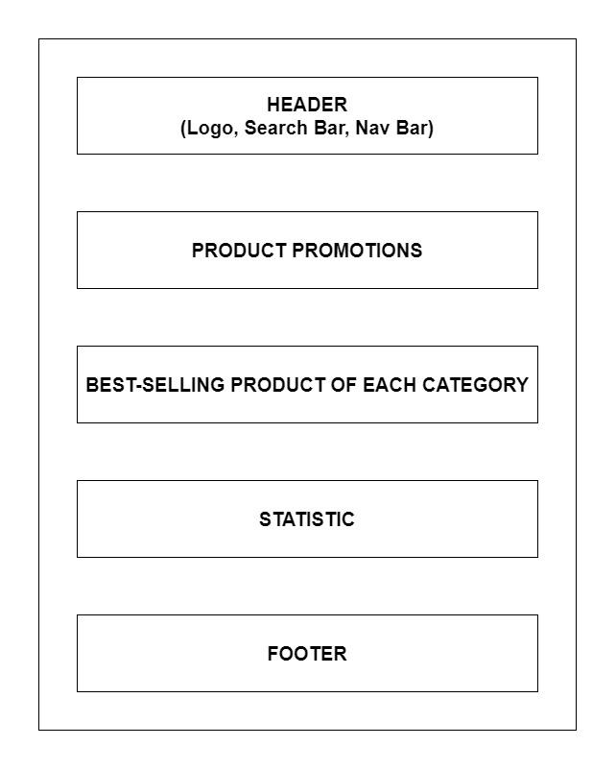

1. **Product**

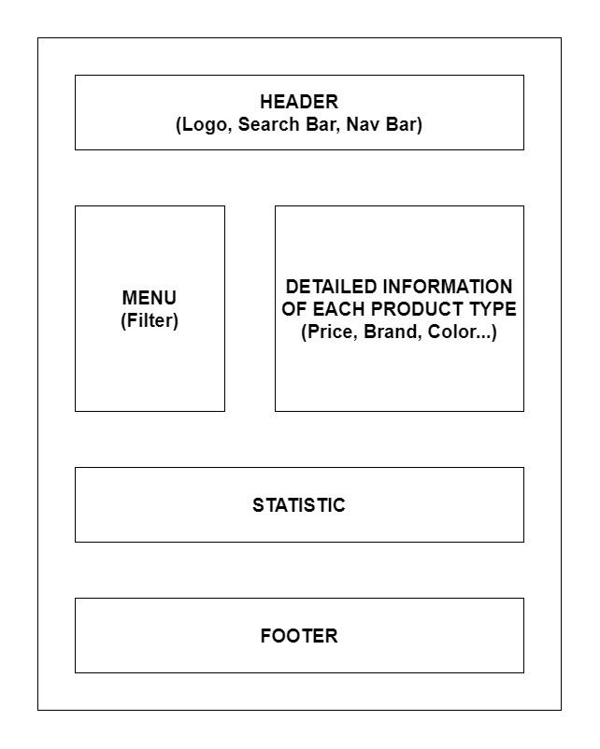

1. **Blog**

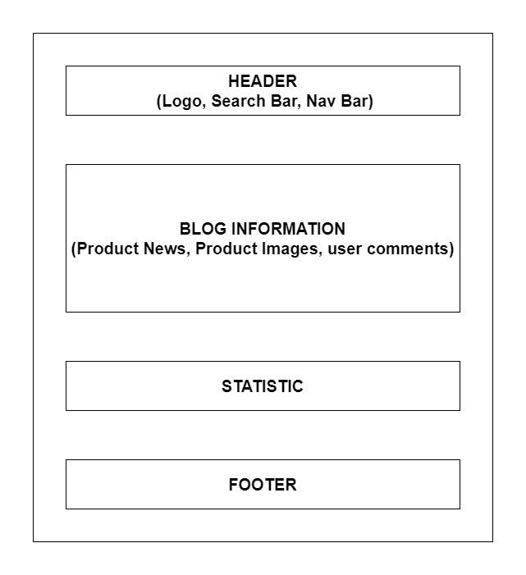

1. **About Us**

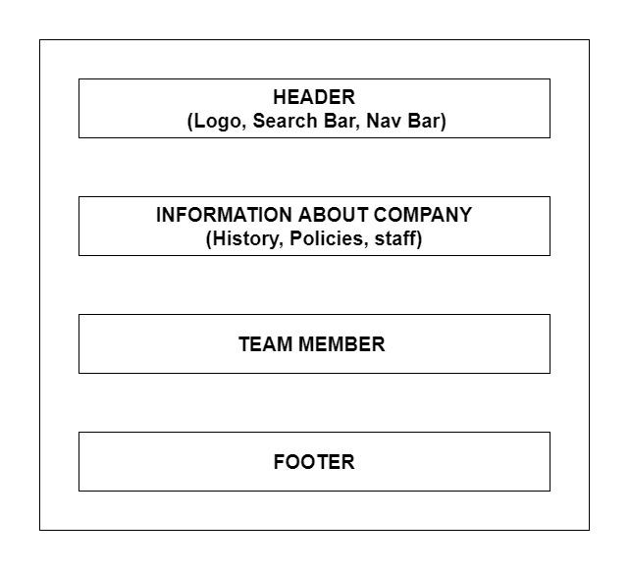

1. **Service**

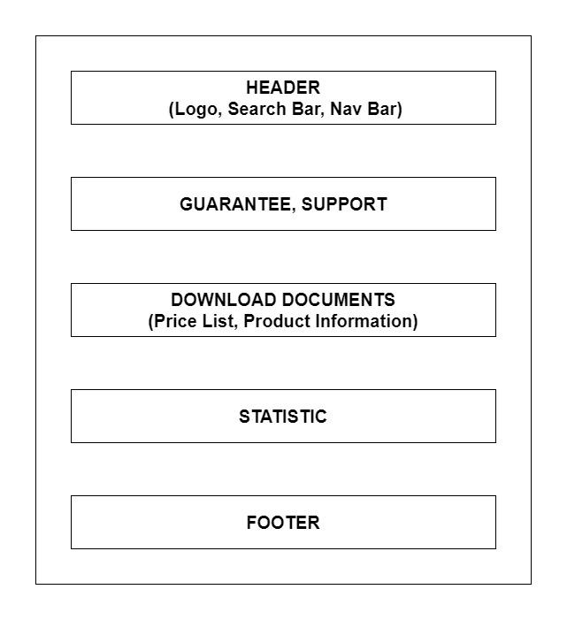

1. **Sign In/ Sign Up**

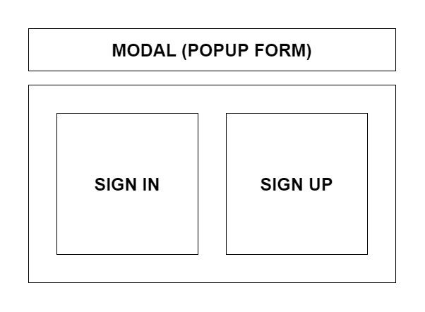

# TASK SHEET REVIEW 2

|  |  |  |  |  |  |  |  |
| --- | --- | --- | --- | --- | --- | --- | --- |
| **Project Ref. No.:**  **eP/Advertisement Portal Management**  **System/01** | | **Project Title:** | **Activity Plan Prepared By:** | **Date of Preparation of Activity Plan:** | | | |
| **Sr.**  **No.** | **Task** | **Actual**  **Start**  **Date** | **Actual Days** | **Team**  **Mate Names** | **Status** |
| 1 | Site Map | CLEAR  REFLECTIONS | Minh | 29-Jun-23 | 1 | Minh | Completed |
| 2 | Mock of the website | 29-Jun-23 | 2 | Thanh | Completed |
| 3 | Task sheet | 29-Jun-23 | 2 | Doanh | Completed |

|  |  |
| --- | --- |
| **Date:** | |
| Signature of Instructor:  **Ms. Le Mong Thuy** | Signature of Team Leader:  **Le Duc Minh** |

# WEBSITE DESCRIPTION

1. **Homepage**
2. Description

Home page displays following information:

- Slide show programs, services and product promotions

- Feature product.

- Best selling product

- Customer review

- Some information about the website.

- Every page has a footer and scrolls to the top

1. Screen shot

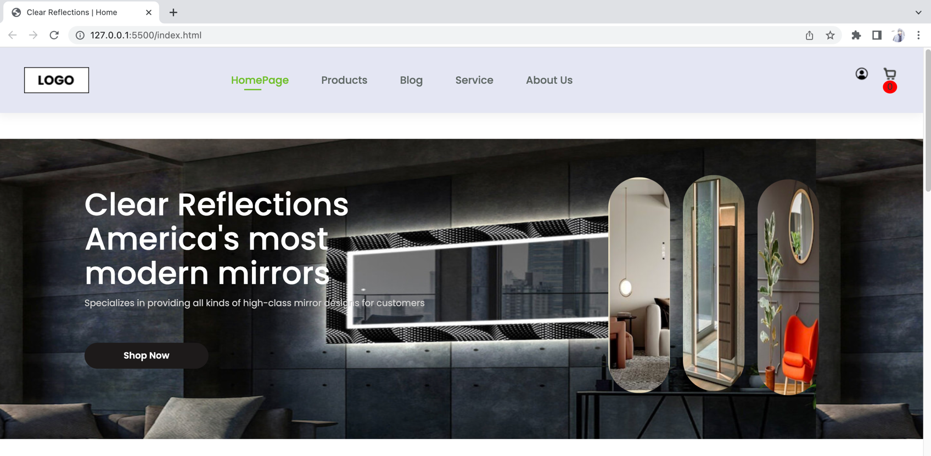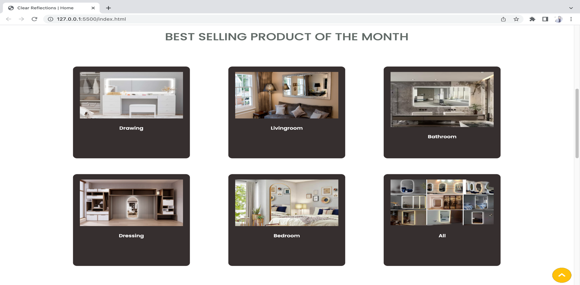

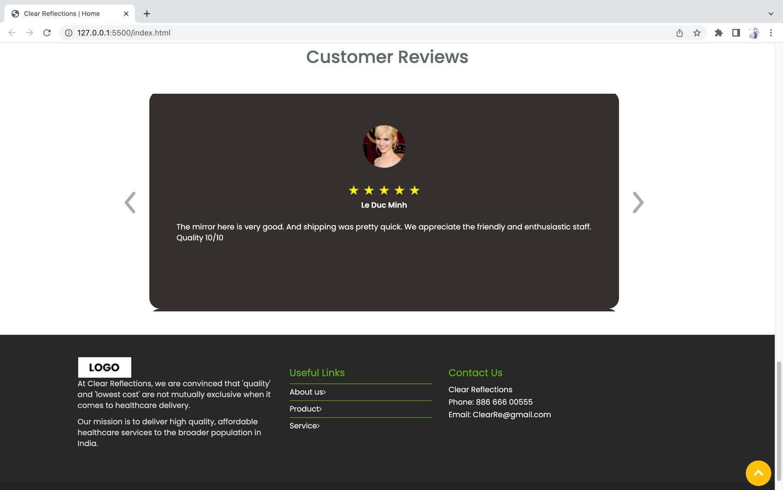

1. **Product**
2. Description

This product page displays following information:

- All product that being sold ClearReflections.

- Menu filter to easily find items based on categories, material.

- Product can sort by price and by name.

-When click”checkout”, transfer to checkout page.

1. Screen shot

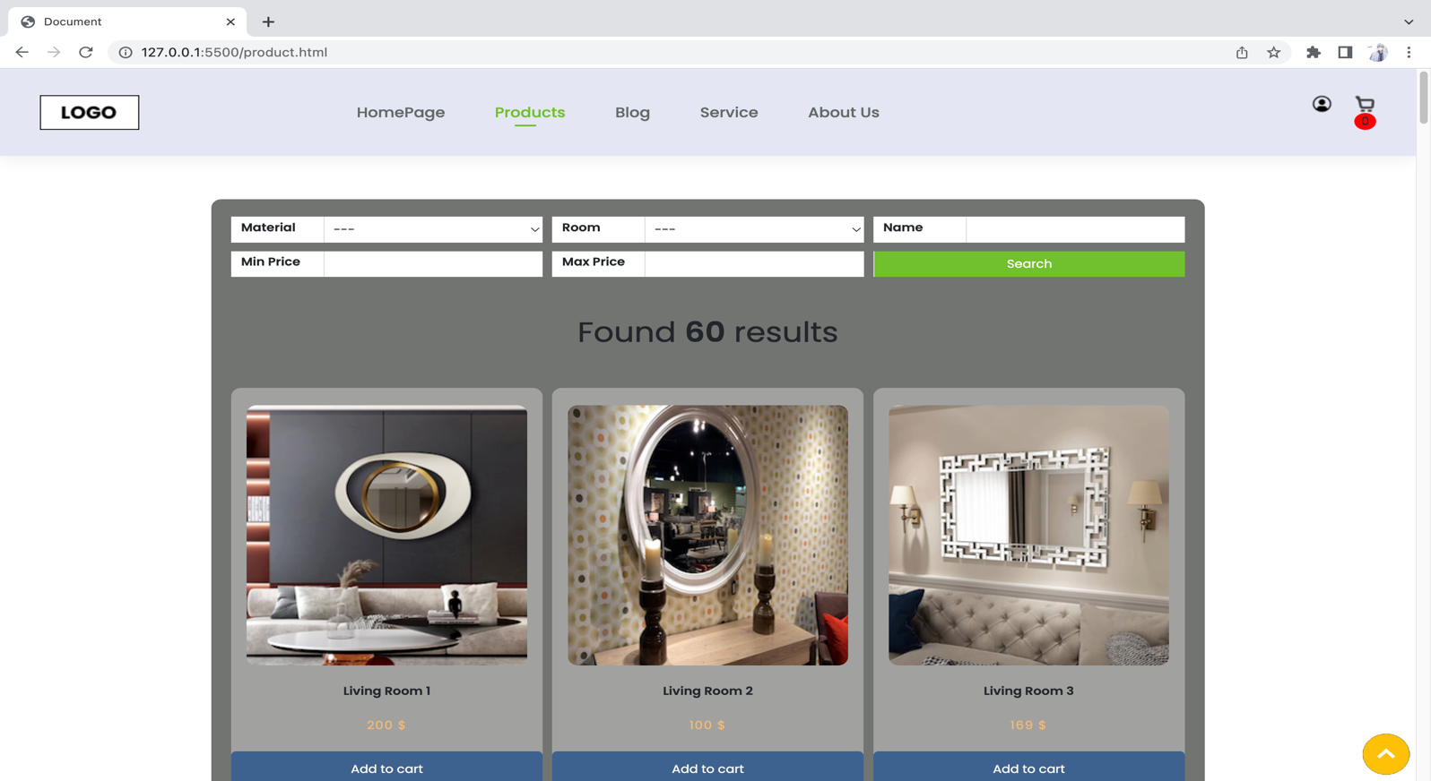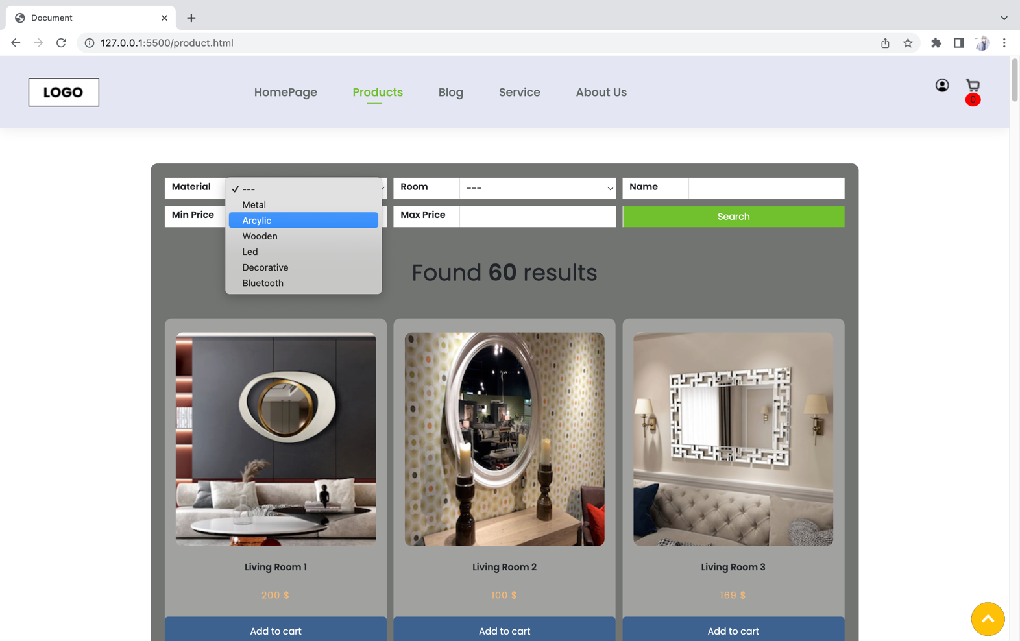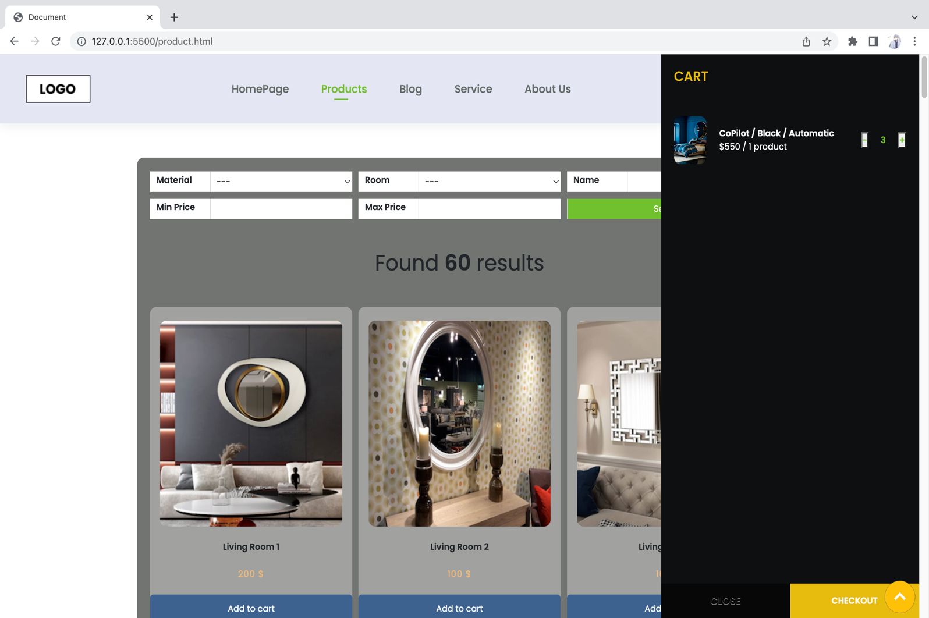

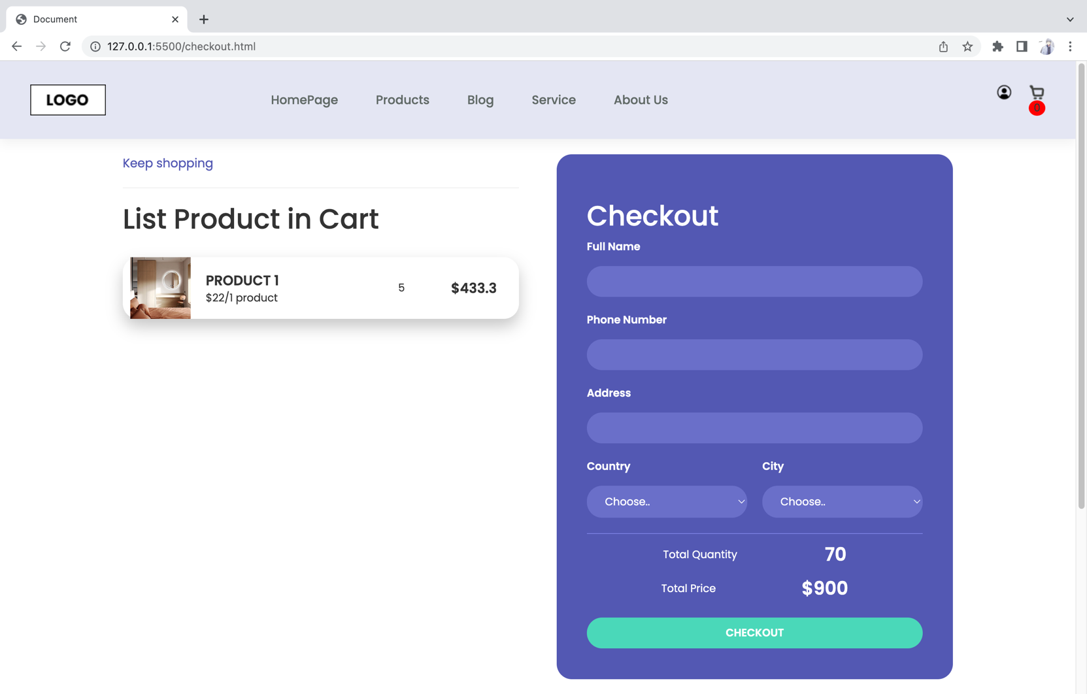

1. **Blog**
2. Description

The blog page displays following information:

- News.

- Information of some product.

- Recommand for customer good products .

1. Screen shot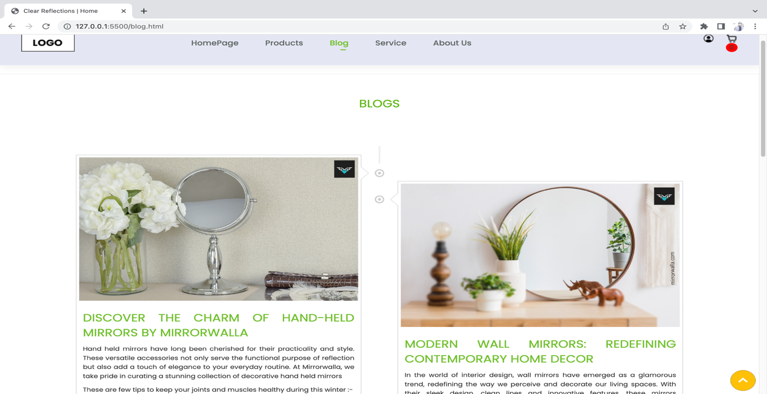

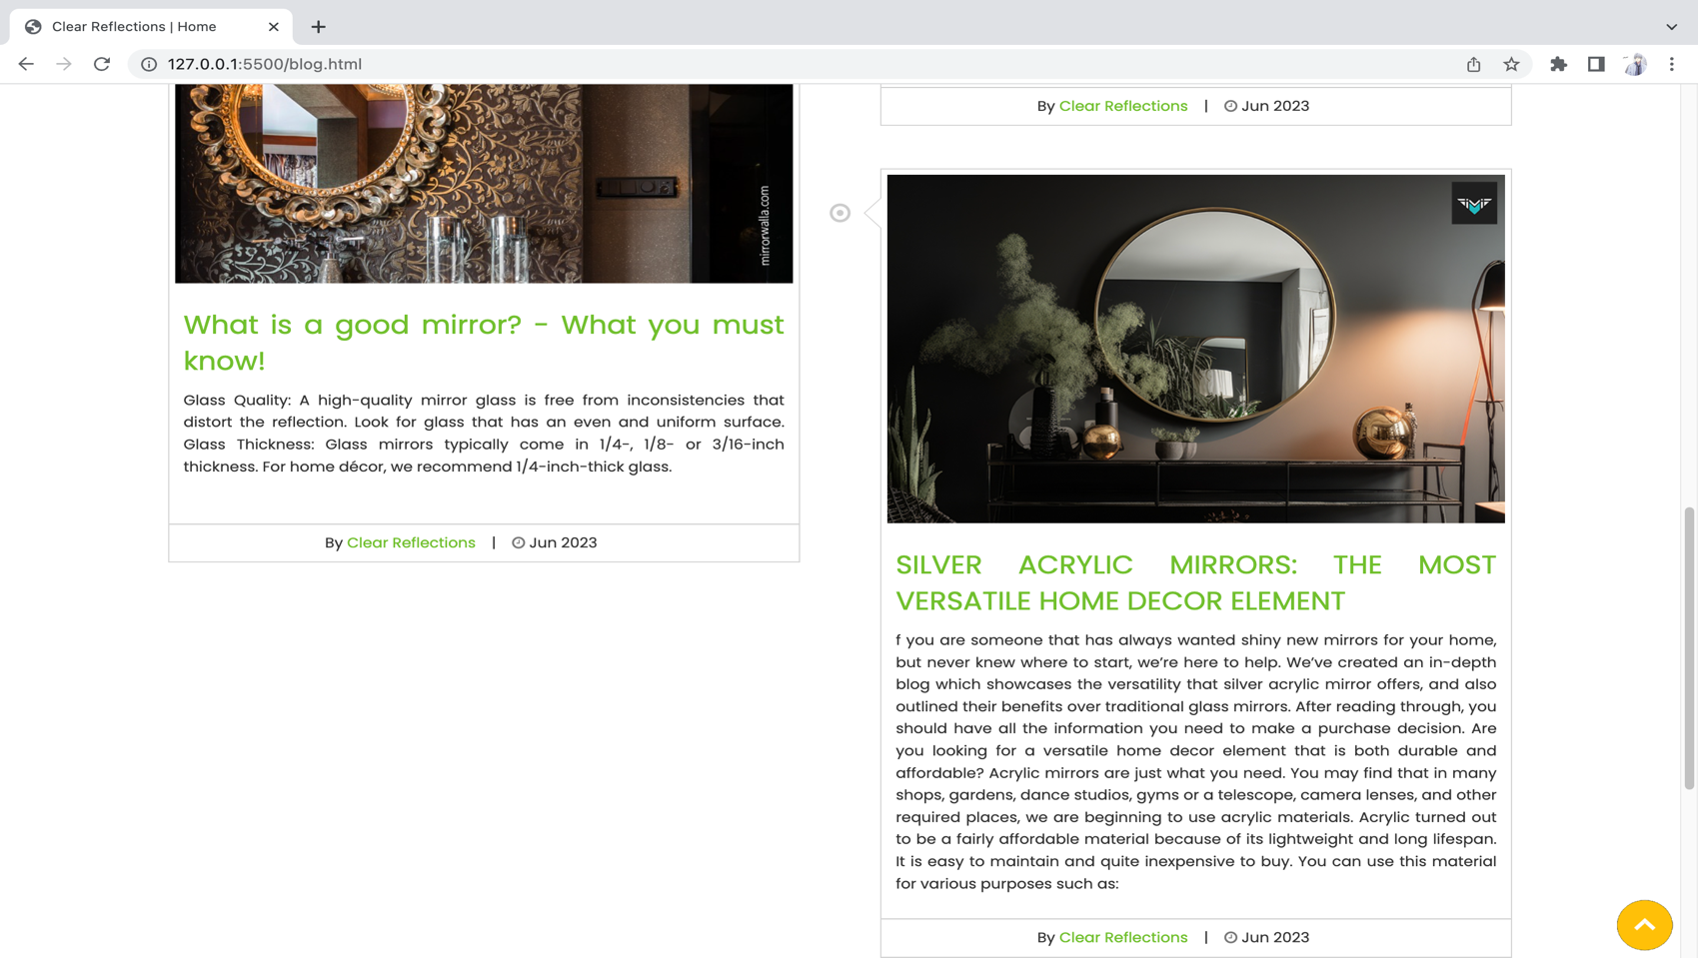

1. **Service**
2. Description

- This page displays information about the service of ClearReflection

- Display informations: mail, phone number and link

1. Screen shot

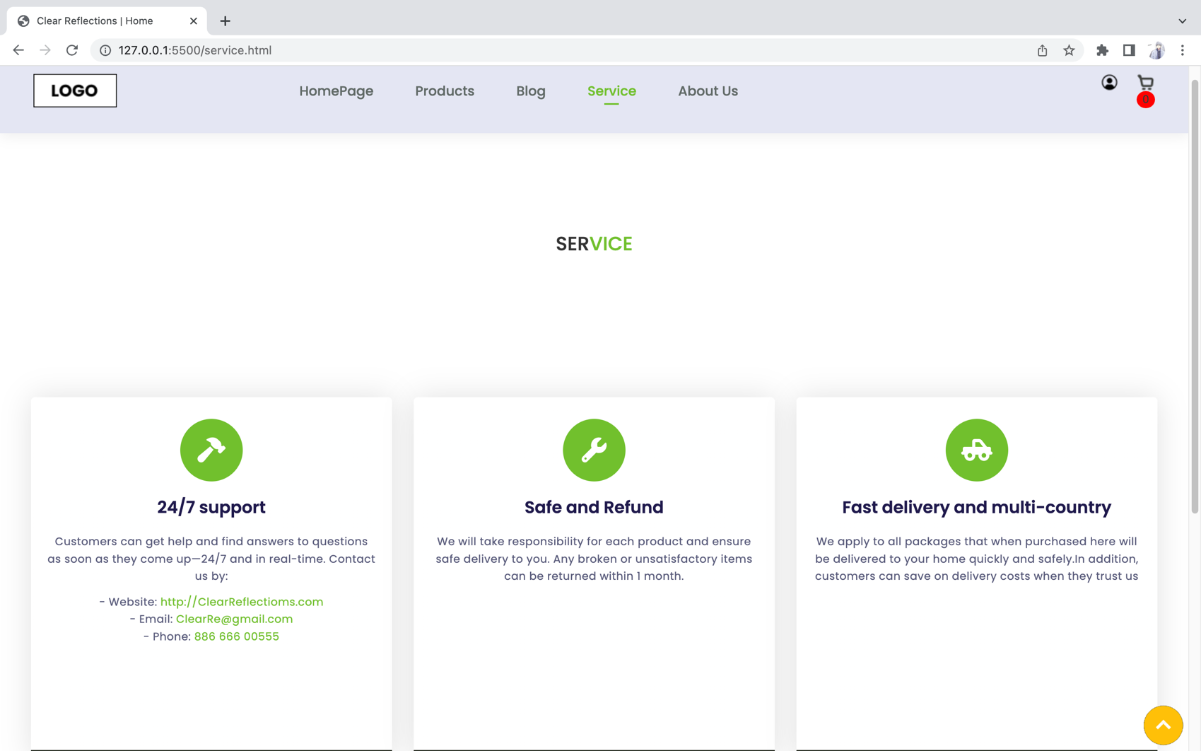

1. **About Us**
2. Description

- This page displays information about the history of Rhythm House, our service that we provide and business hours

- Display location.

1. Screen shot

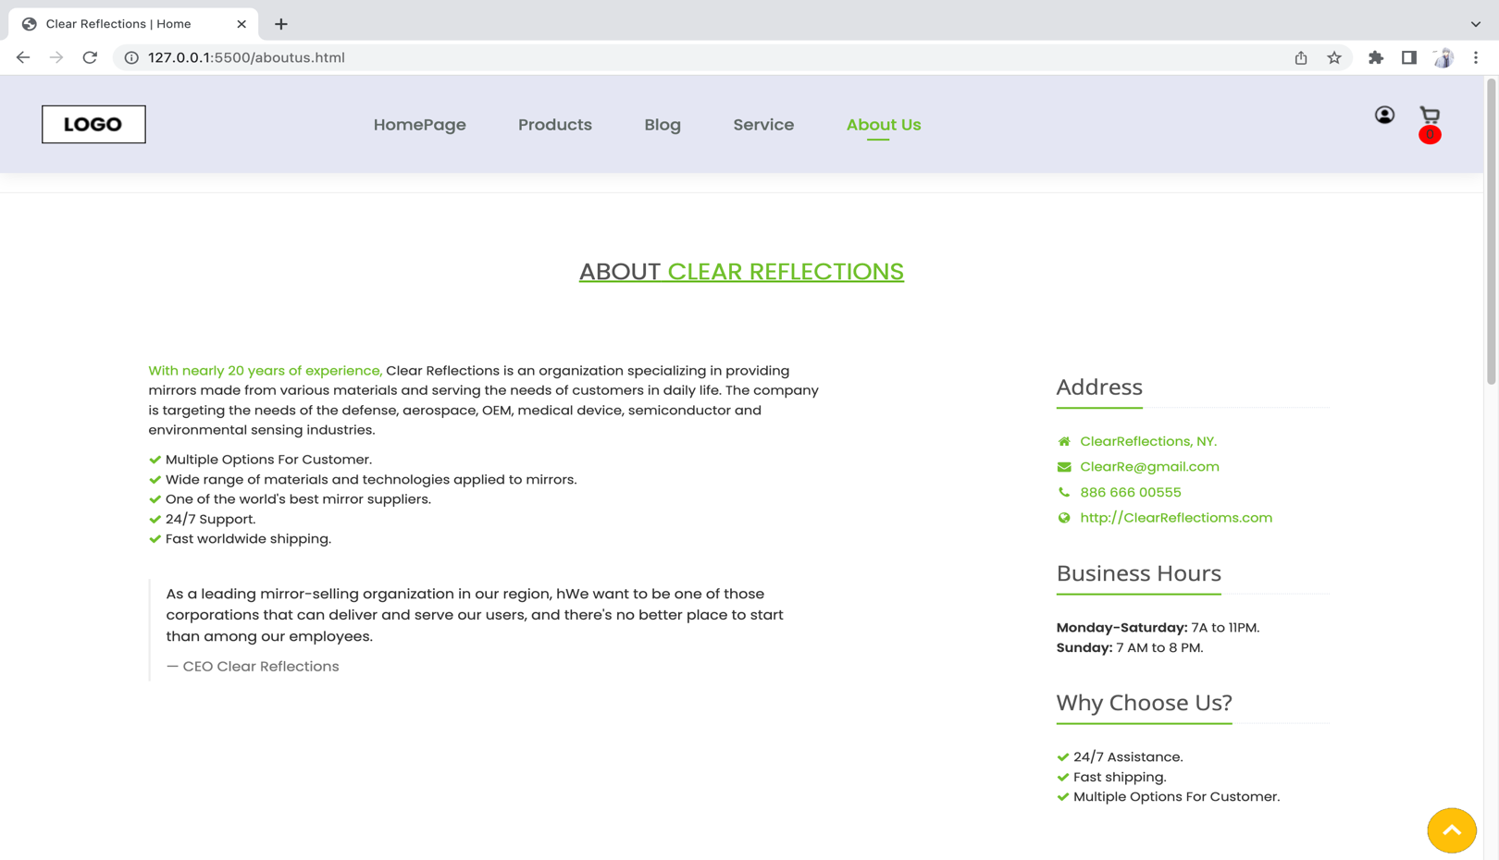

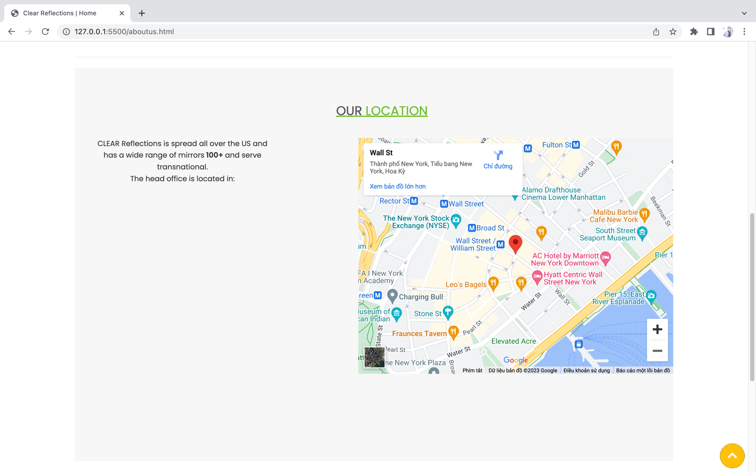

1. **Login/ Register**
2. Description

- When Click the logo personal on the top, transfer to login page.

- This page displays information: information, review about product.

- Customer can create account and register for this page.

Screen shot

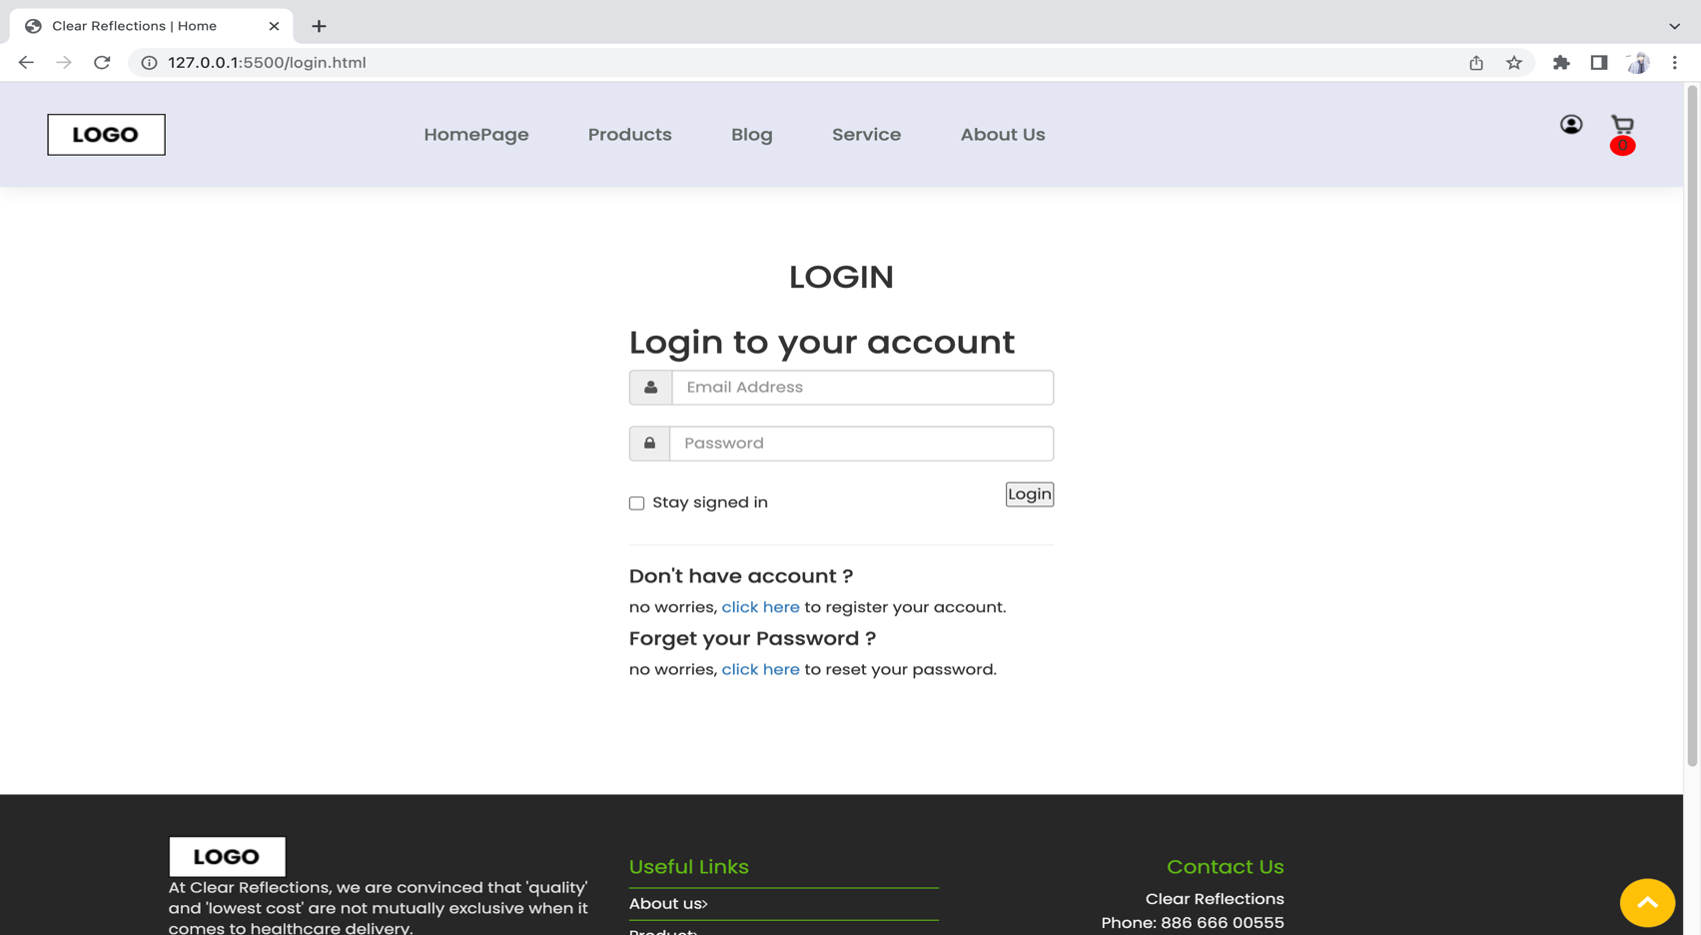

1. 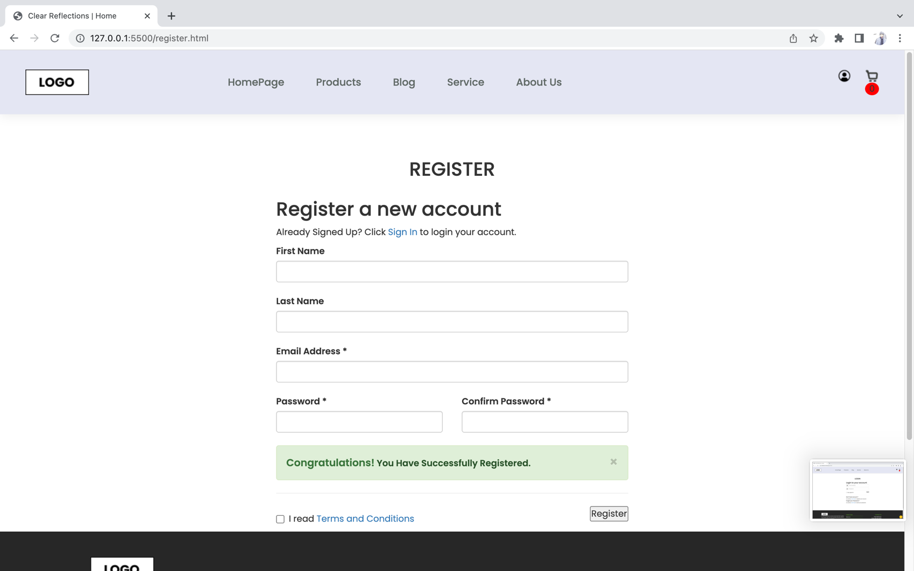

**RESPONSIVE**

The page has responsive feature for small screen device such as smart phone, tablet, etc.

* + 1. 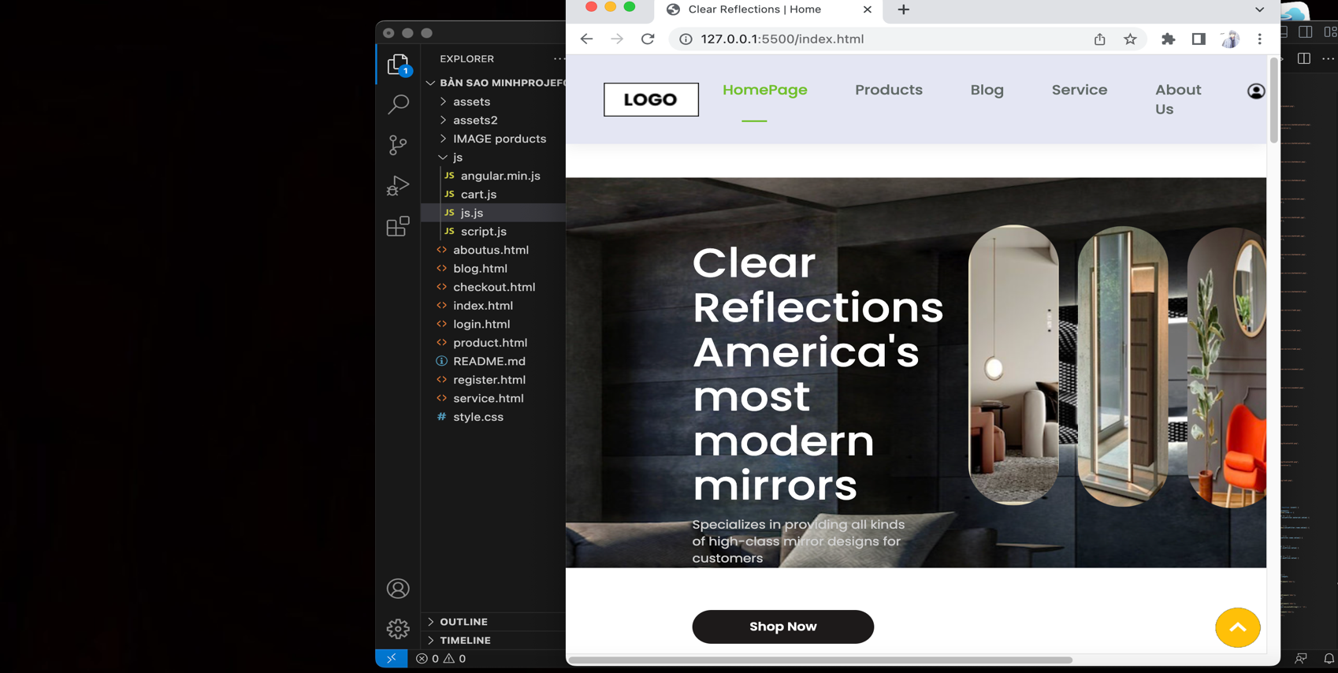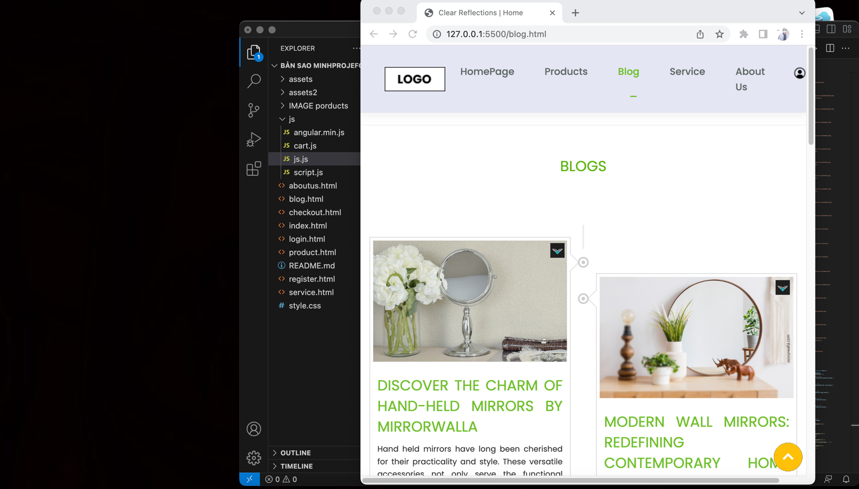

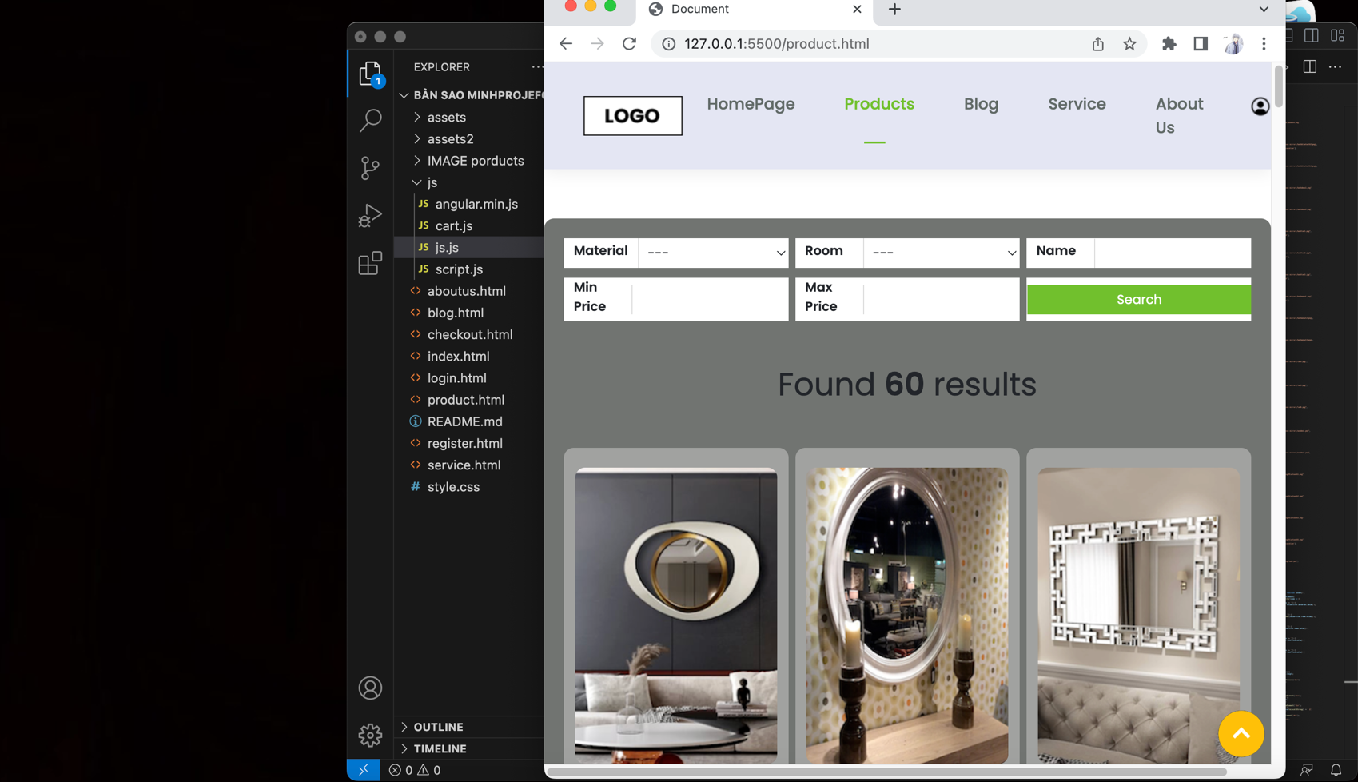

**JAVASCRIPT DESCRIPTION**

1. **Slider Javascript**
2. Description

This script used SLIDE package (carousel) to display the comment of customer on the website.

1. Screen shot

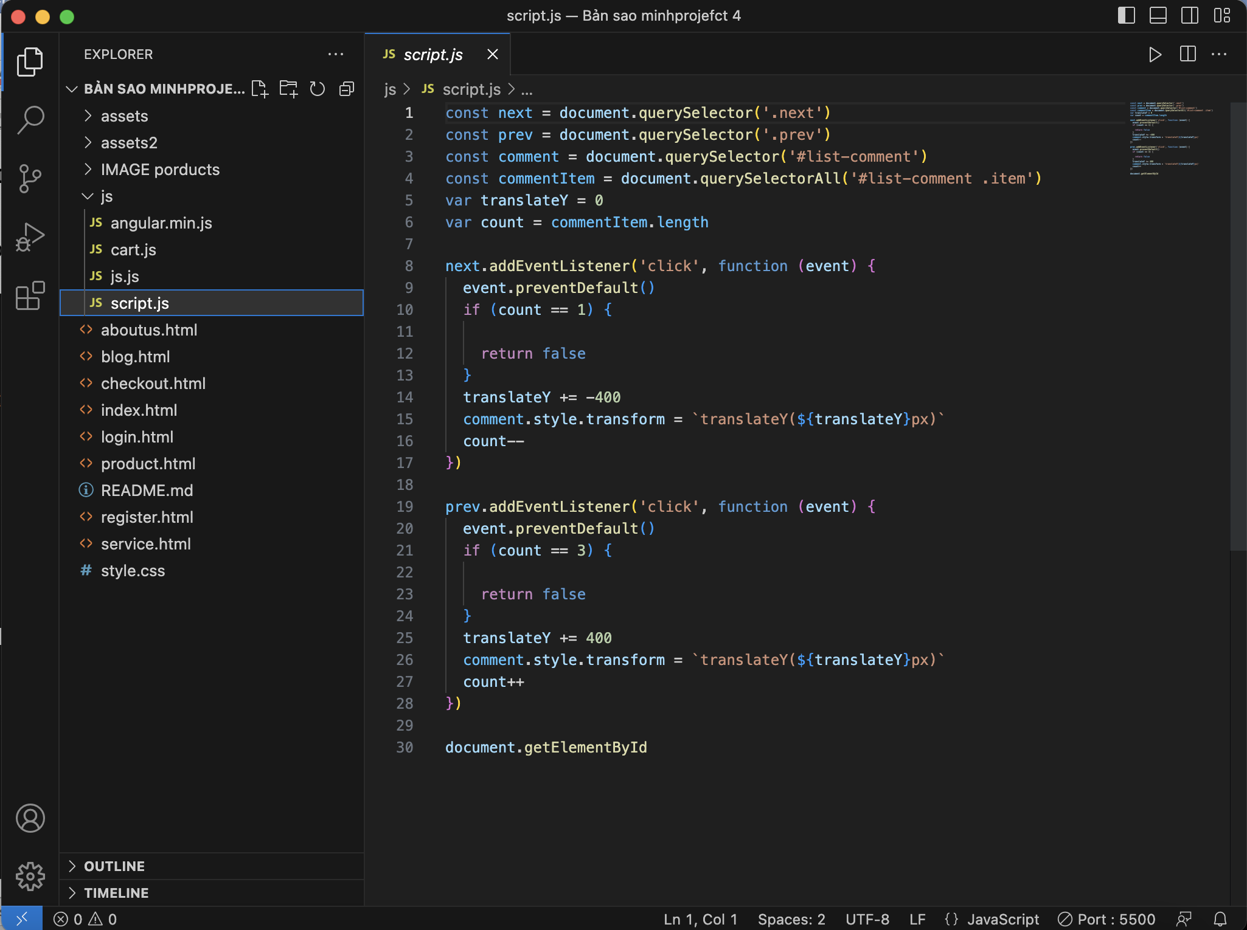

1. **File Jason**
2. Description

this script contains data with all the information of the item

1. Screen shot

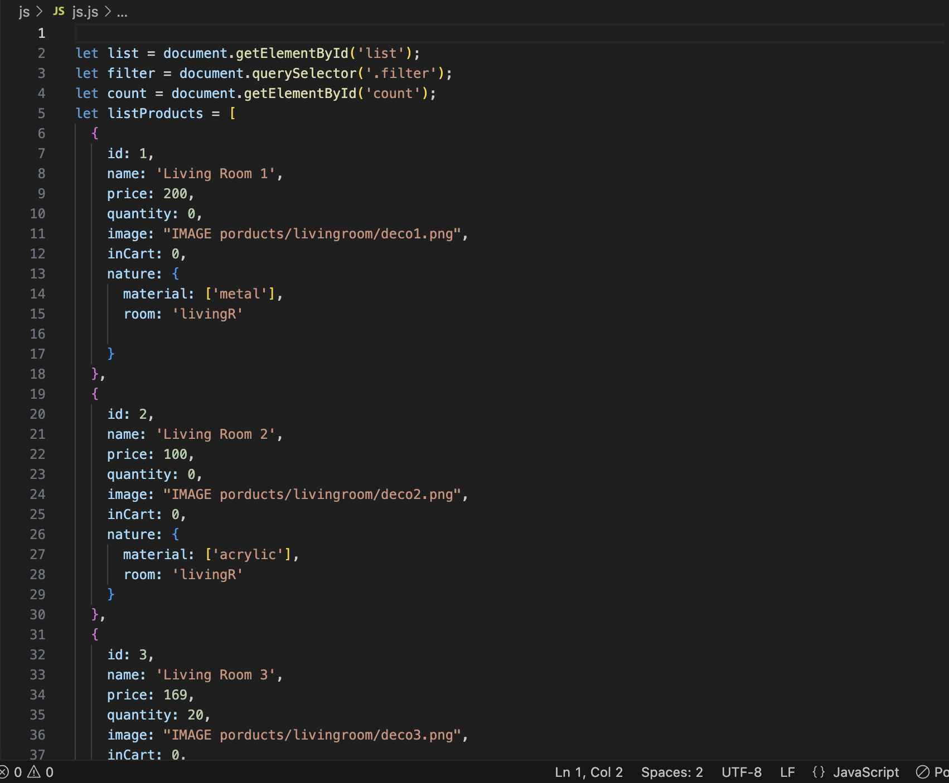

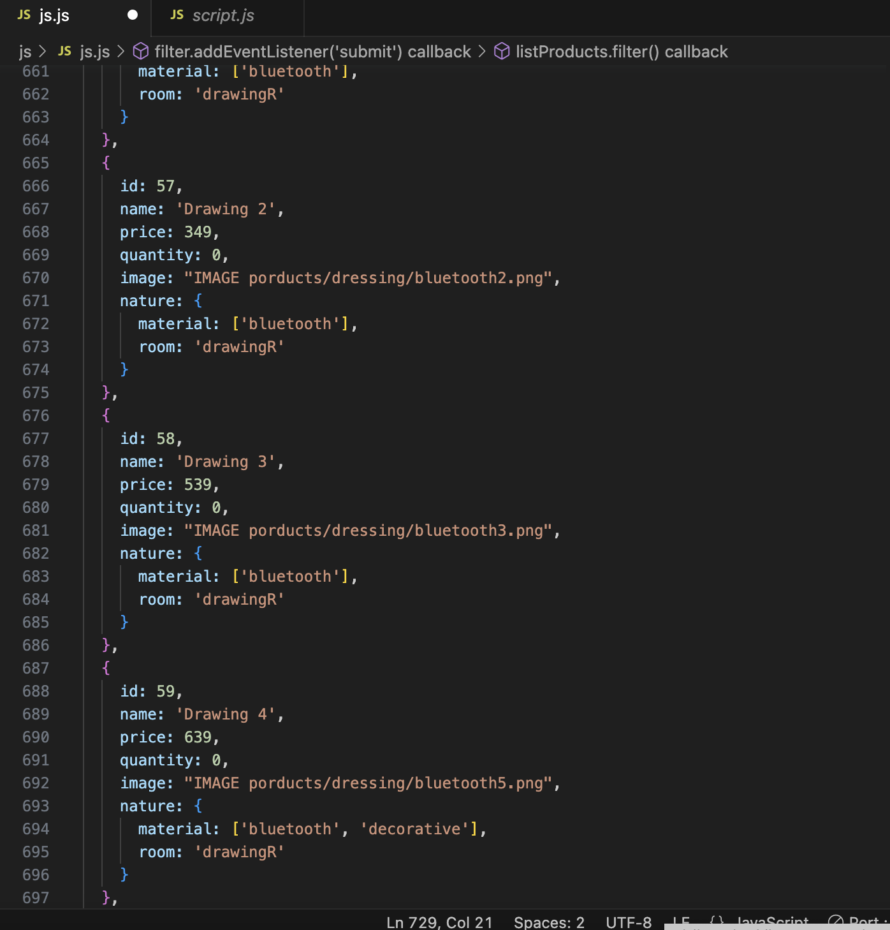

1. **Filter Javascript**
2. Description

This script is used to filter the product list by Type, Brand, Feature, Category,Material and Price.

1. Screen shot

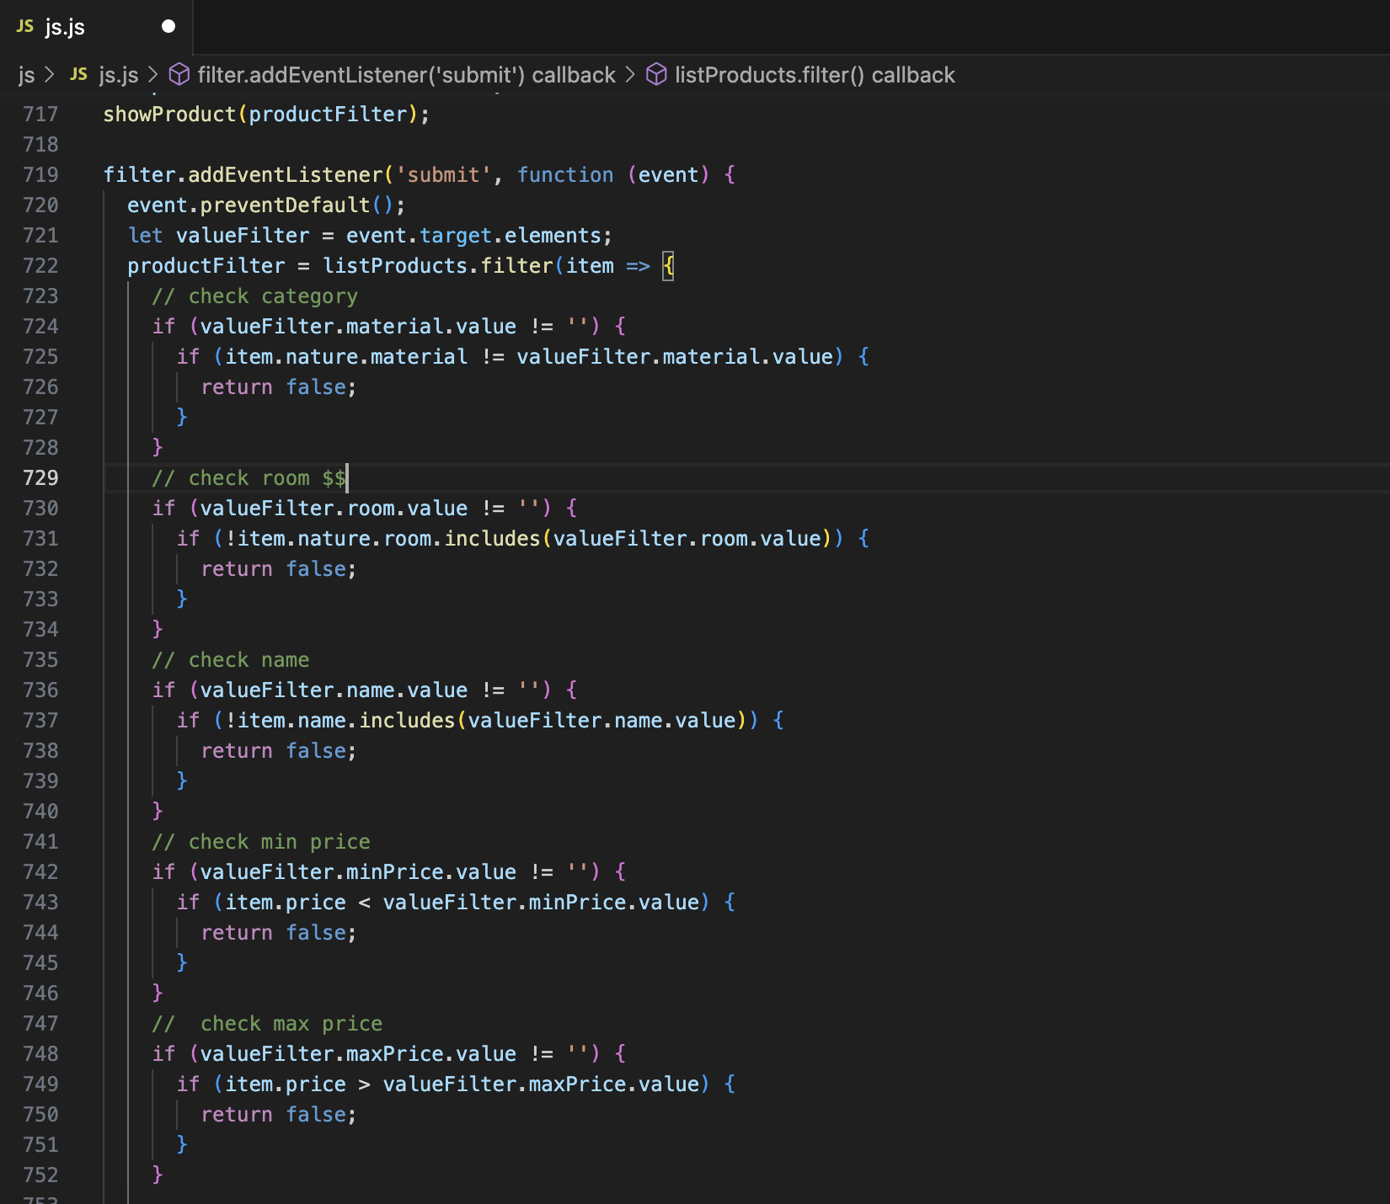

1. **Get data to main page**
2. Description

This script is used to show all information products to main page.

1. Sreen shot

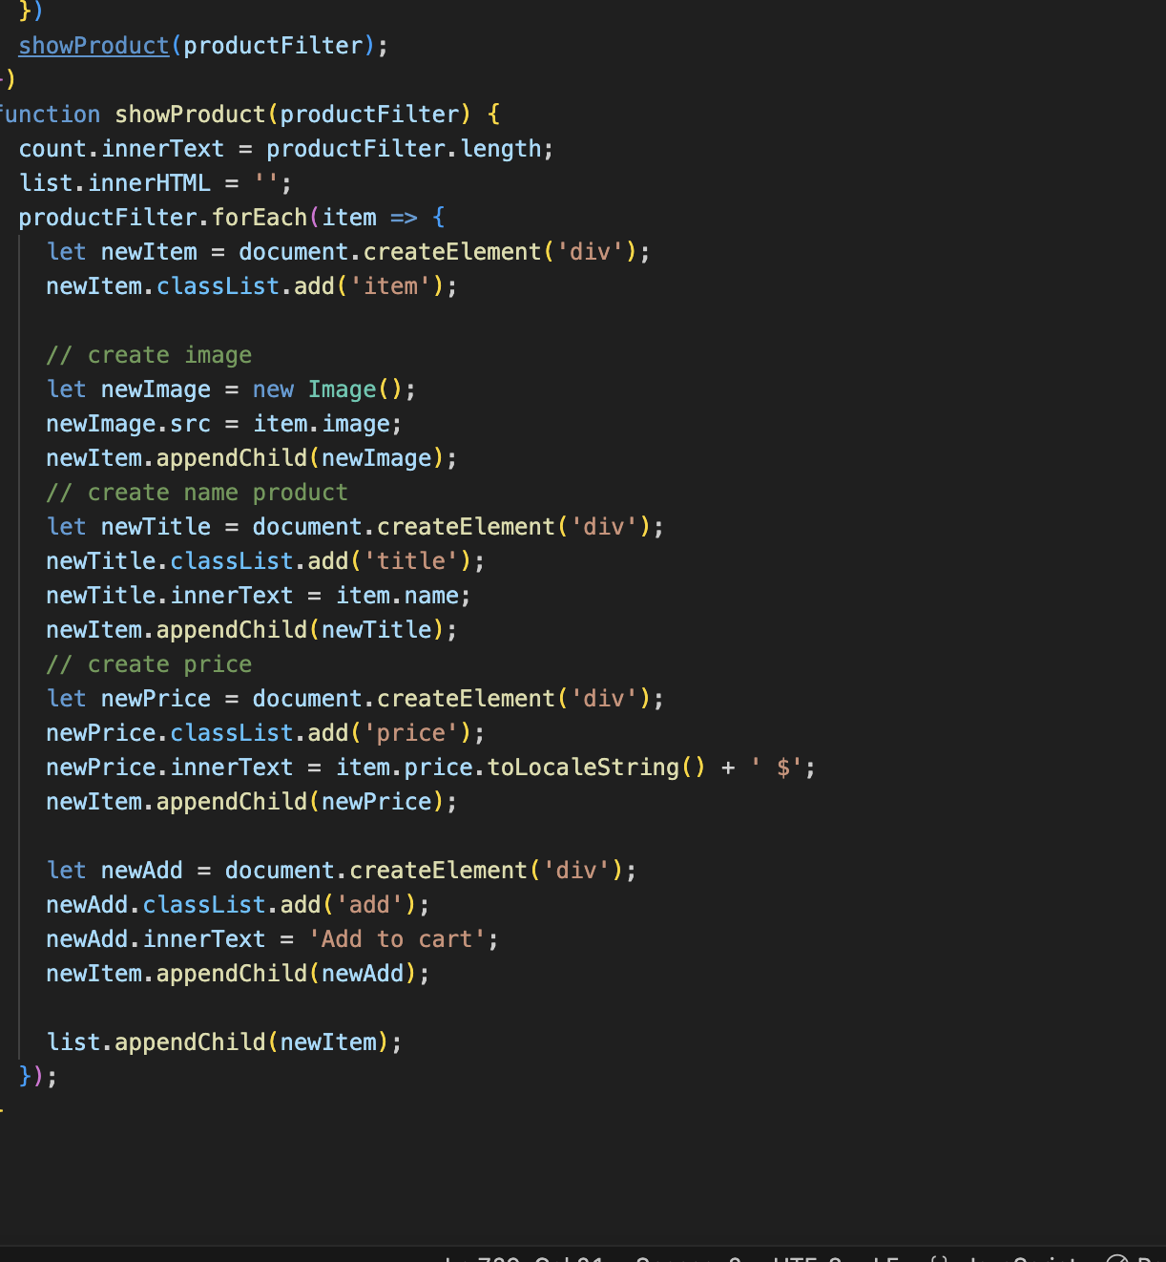

1. **Show cart**

1. Description

This script is used to show the cart for website.

1. Sreen shot

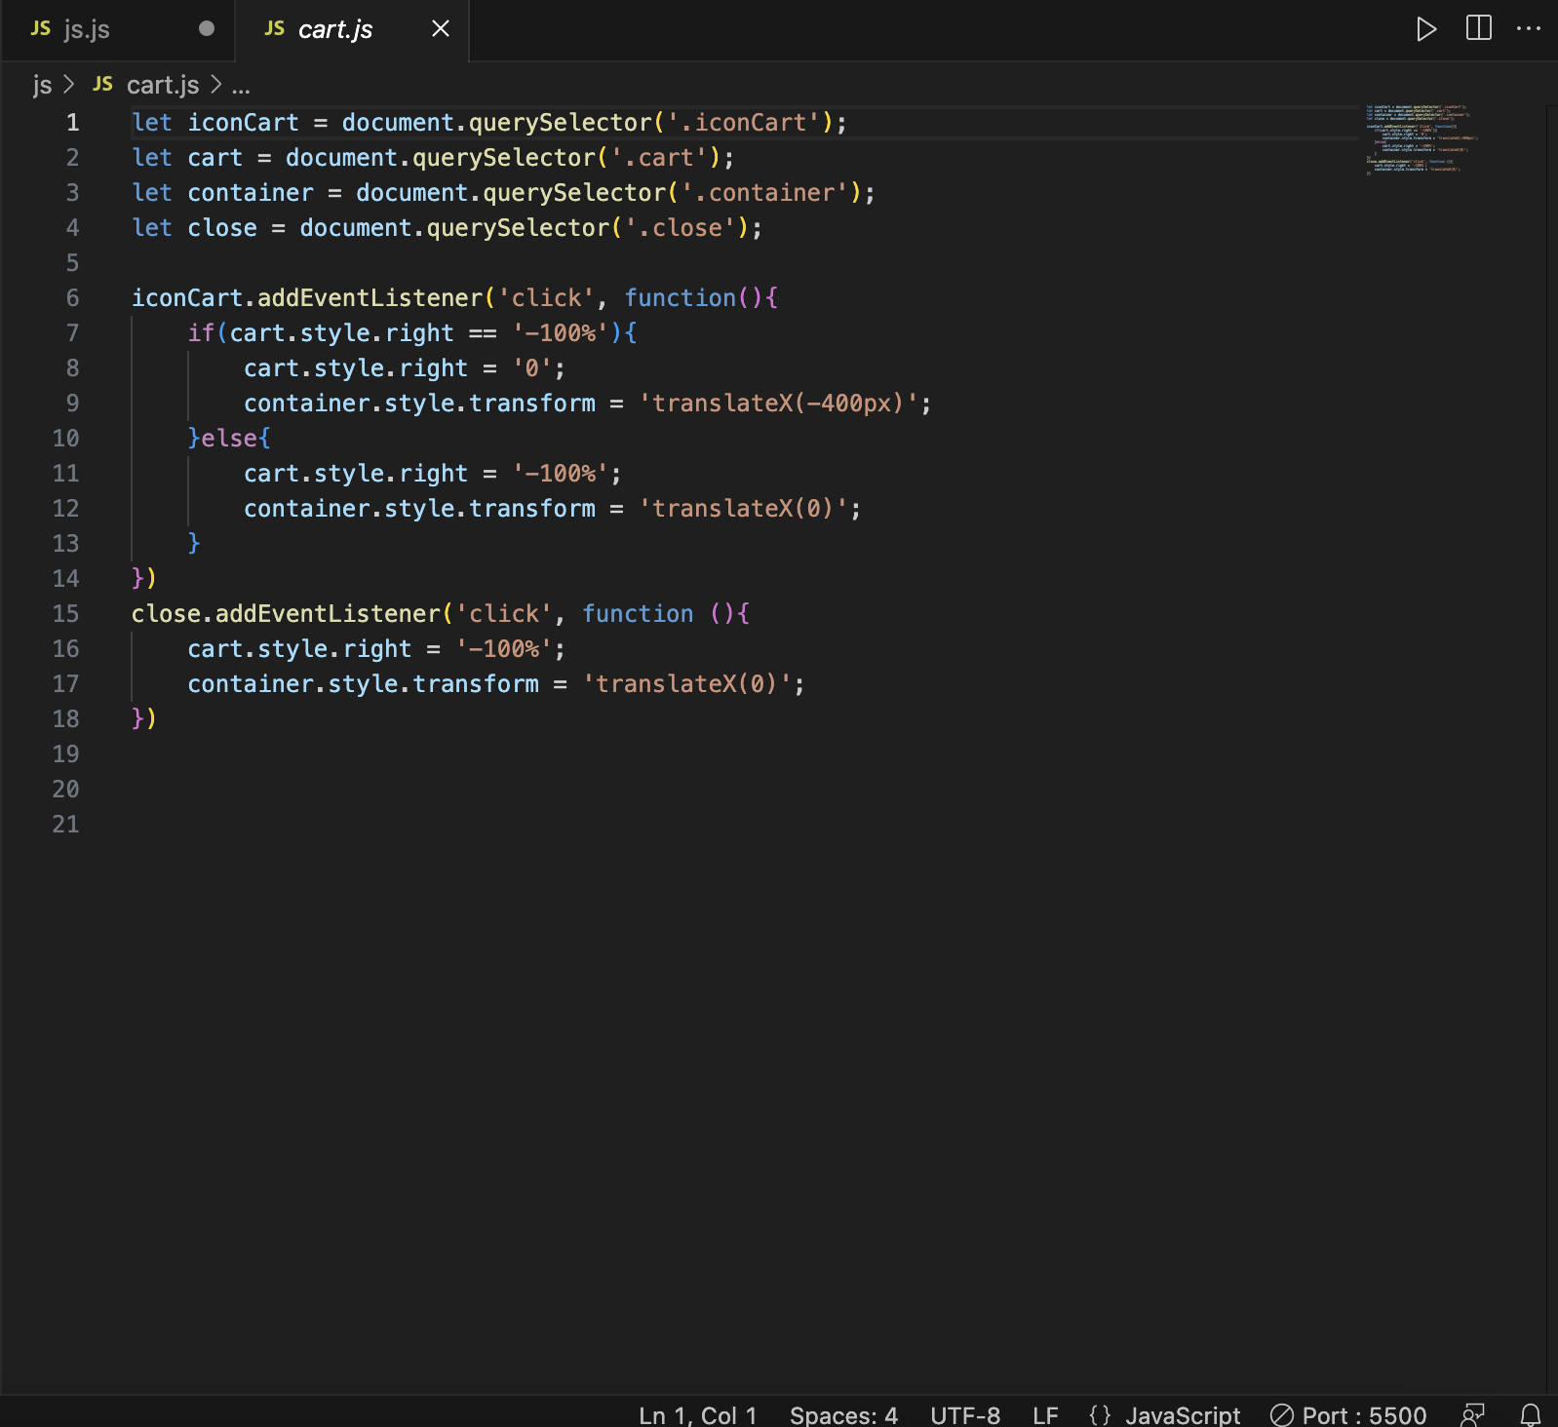

# TASK SHEET REVIEW 3

|  |  |  |  |  |  |  |  |
| --- | --- | --- | --- | --- | --- | --- | --- |
| **Project Ref. No.:**  **eP/Advertisement Portal Management**  **System/01** | | **Project Title:** | **Activity Plan Prepared By:** | **Date of Preparation of Activity Plan:** | | | |
| **Sr.**  **No.** | **Task** | **Actual**  **Start**  **Date** | **Actual Days** | **Team**  **Mate Names** | **Status** |
| 1 | Home Page | Clear Reflection | Minh | 20-Jun-23 | 1 | Minh | Completed |
| 2 | Product | 20-Jun-23 | 3 | Thanh | Completed |
| 3 | Blog | 20-Jun-23 | 2 | Doanh | Completed |
| 4 | About Us | 20-Jun-23 | 2 | Doanh | Completed |
| 5 | Contact Us | 20-Juln-23 | 2 | Thanh | Completed |
| 6 | Service | 25-July-23 | 2 | Thanh | Completed |
| 7 | Sign In/ Sign Up | 25-July-23 | 1 | Doanh | Completed |
| 8 | Java Script | 10-July-23 | 2 | Minh | Completed |
| 9 | Responsive | 10-July-23 | 1 | Minh | Completed |

|  |  |
| --- | --- |
| **Date:** | |
| Signature of Instructor:  **Ms. Le Mong Thuy** | Signature of Team Leader:  **Le Duc Minh** |